

**Department of Electronics & Telecommunication Engineering**

**A Report**

On

**Acccident Detection And Alert**

Submitted in partial fulfillment of the syllabus

of

**Microcontroller**

**Third Year B. Tech. (Sem-V)**

**Submitted By*:***

Divyani Deepak NangareRoll No 47

Rushikesh Pradeep Powar Roll No 57

Swarada Chandrsahekhar Phadnis Roll No 58

Shradhha Santosh Shigaonkar Roll No 60

**Under the guidance of**

**Mr. V. B. Gundavade**



**Department of Electronics & Telecommunication Engineering**

**CERTIFICATE**

We hereby certify that the work which is being presented in Project Based Learning entitled “**Accident Detection And Alert**” by, Divyani Deepak Nangare Roll No 34,Rushikesh Pradeep Powar Roll No 57,Swarada Chandrsahekhar Phadnis Roll No 58,Shradhha Santosh Shigaonkar Roll No 60, in partial fulfillment of requirement of the syllabus of Microcontroller Third Year B. Tech. (Sem-V) submitted to department of Electronics and Telecommunication Engineering, KIT’s College of Engineering, Kolhapur (Autonomous) is our own work carried out during the period July to October 2019 under the supervision of

Mr. V. B. Gundavade

Signature of the students.

Divyani Deepak Nangare

Rushikesh Pradeep Powar

Swarada Chandrsahekhar Phadnis

Shradhha Santosh Shigaonkar

This is certified that the above statement made by the candidate is correct to the best of my knowledge.

Signature of Guide

Mr. V. B. Gundavade

Assistant Professor

**ACKNOWLEDGEMENT**

We take the opportunity to express our deep sense of gratitude & respect towards all who helped us to complete our project. We sincerely & humbly express our gratefulness to our guide **Mr. V. B. Gundavade** **(Department of Electronics & Telecommunication, KIT’s College of Engineering)** & thank him for his valuable support, guidance, encouragement & cooperation without which this project would not be completed. Last but certainly not the least we extend our gratefulness to teaching & nonteaching staff members of Electronics & telecommunication department & to all our dear friends who have directly or indirectly helped in completion of this project.

Your Sincerely,

## INDEX

|  |  |  |
| --- | --- | --- |
| **Sr. No.** | **Title** | **Page No.** |
| 1 | ABSTRACT | 01 |
| 2 | INTRODUCTION | 02 |
| 3 | PROBLEM STATEMENT | 03 |
| 6 | SYSTEM STRUCTURE | 04 |
| 7 | IMPLEMENTATION TOOLS | 05 |
| 8 | HARDWARE DESCRIPTION | 06 |
| 9 | CIRCUIT DIAGRAM AND SIMULATION | 08 |
| 10 | SOFTWARE DESIGN | 09 |
| 11 | CONCLUSION | 14 |
| 12 | FUTURE SCOPE | 15 |
| 13 | REFERENCES | 16 |

### ABSTRACT

This project is Accident Detection And Alerting System Using 8051 Microcontroller. When an individual riding his/her bike, meets with an accident, there is a chance that the individual may suffer from a serious injury or expire instantaneously and there is no one around to help him. Well this system is a solution to the problem. The system acts as an accident identification system that gathers and sends this vehicle information that met with an accident, and conveys it to the nearest control room.

For this the user vehicle is fixed with a GSM module and vibration sensor along with microcontroller. Whenever a user vehicle meets with any accident, the vibration sensor detects and gives its output. This output is then detected by the microcontroller. Now the microcontroller sends this change detection signal to a GSM Module. GSM Module begins sending the accident data by SMS. We can give anyone number. For example police number, ambulance number, doctor number etc. Here we are also using LCD Module. This displays the status. Whenever accident happens buzzer will activate.

.

### INTRODUCTION

In present days the rate of accidents can be increased rapidly. Due to employment the usage of vehicles like cars, bikes can be increased, because of this reason the accidents can be happened due to over speed. People are going under risk because of their over speed, due to unavailability of advanced techniques, the rate of accidents can’t be decreased.

To reduce the accident rate in the country this project introduces a optimum solution. Automatic alert system for vehicle accidents is introduced; the main objective is to control the accidents by sending a message to the registered mobile using wireless communications techniques.

When an accident occurs at a city, the message is sent to the registered mobile through GSM module in less time. Microcontroller and GSM is the heart of the system which helps in transferring the message to different devices in the system. Vibration sensor will be activated when the accident occurs and the information is transferred to the registered number through GSM module. GPS system will help in finding the location of the accident spot. The proposed system will check whether an accident has occurred and notifies to nearest medical centers and registered mobile numbers about the place of accident using GSM and GPS modules. The location can be sent through tracking system to cover the geographical coordinates over the area. The accident can be detected by a vibration sensor which is used as major module in the system.

### PROBLEM STATEMENT

### Basically this system provides the safety during the transportation. As the usage of vehicles is increasing drastically, the hazards due to vehicles is also increased. The main cause for accidents is high speed, drunk and drive, diverting minds, over stress and due to electronic gadgets. This paper deals with accident detection system that occurs due to carelessness of the person who is driving the vehicle. This introduces accident alerting system which alerts the person who is driving the vehicle. If the person is not in a position to control the vehicle then the accident occurs. Once the accident occurs to the vehicle this system will send information to registered mobile number.

### SYSTEM STRCTURE

### C:\Users\cfl3\Desktop\accident-detection-and-alerting-system-using-8051.png

### IMPLEMENTATION TOOLS

Hardware :-

* 8051 Microcontroller
* 8051 Development board
* LCD Module
* GSM Module
* Vibration Sensor
* Buzzer
* Capacitors

Software :-

* Proteus
* Keil IDE

### HARDWARE DESCRIPTION

1. **AT89C51**:

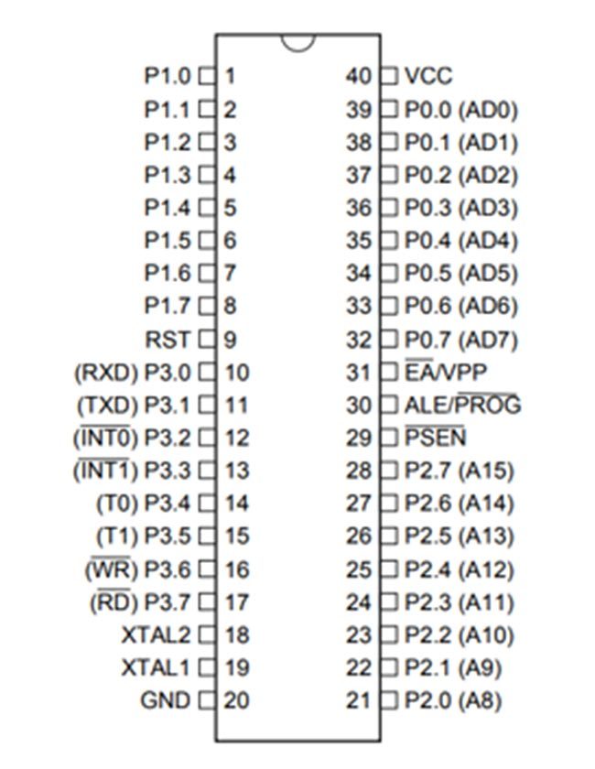AT89C51 is an 8-bit microcontroller and belongs to Atmel's 8051 family. ATMEL 89C51 has 4KB of Flash programmable and erasable read only memory (PEROM) and 128 bytes of RAM. It can be erased and program to a maximum of 1000 times. In 40 pin AT89C51, there are four ports designated as P1, P2, P3 and P0. All these ports are 8-bit bi-directional ports, i.e., they can be used as both input and output ports. Except P0 which needs external pull-ups, rest of the ports have internal pull-ups.

When 1s are written to these port pins, they are pulled high by the internal pull-ups and can be used as inputs. These ports are also bit addressable and so their bits can also be accessed individually. Port P0 and P2 are also used to provide low byte and high byte addresses, respectively, when connected to an external memory. Port 3 has multiplexed pins for special functions like serial communication, hardware interrupts, timer inputs and read/write operation from external memory. AT89C51 has an inbuilt UART for serial communication. It can be programmed to operate at different baud rates. Including two timers & hardware interrupts, it has a total of six interrupts.

1. **VIBRATION SENSOR:**

In case of any accident, the vibration in vibration sensor increases the limit and information to the GSM module. The GSM module can send message to respective authority. Thus this system ensures the life security. In information sending module module GSM vibration sensor are used. In this, the system vibration sensor, GSM is placed in the vehicle. If an accident occurred the vibration sensor senses the vibration level and if it exceeds the threshold limit the system will consider that there is an occurrence of accident in that particular location.

1. **GSM MODEM:**

GSM product provides full functional capability to serial devices to send sms. The product is available as broad level or enclosed in metal box. The product has sim card holder to which 5V Regulated power supply activated sim card is inserted for normal use. It provides great feasibility for devices in remote location to stay connected which otherwise would not have been possible where telephone lines does not exist.

1. **LCD MODULE:**

To display the numbers, alphabets and special characters an LCD module with 16x2 alphanumeric types is used. RS and E pins of LCD are connected to pin 12 and 13. To perform the write operation on LCD the read/write pin is connected to ground.

The controller used in this for controlling all the modules in the circuit. The two major parts other than controller is GSM to receive the coordinates of the vehicle. GSM will send the received coordinates to the user through SMS. There is an additional LCD which is used for displaying status message or coordinates. When a person is driving the vehicle met with an accident then the vibrations of the vehicle is received by the vibration sensor and the sensor acts as a accident detection module which further send the information to the micro controller and the location of the vehicle is received through GPS module and the coordinates of the vehicle is send to the GSM module. The received coordinate’s information is collected and is send to the respected person through SMS.

### CIRCUIT DIAGRAM AND SIMULATION

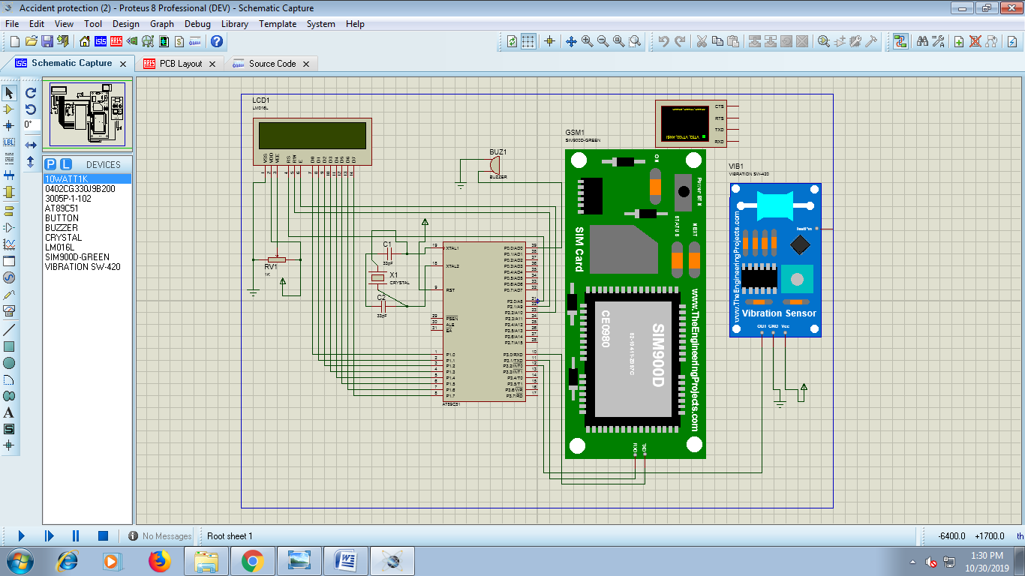

### SOFTWARE DESIGN

#include<reg51.h>

#define NUMBER1 "9075412608" //Enter the mobile number

#define NUMBER2 "9975239845"

#define NUMBER3 "9657574342"

#define LCDDATA P1

#define DELAY for(i=0;i<1200;i++)

void comwrt(unsigned char);

void datawrt(unsigned char);

void LCD_initialise();

void display(unsigned char *str);

void sendSMS(unsigned char *num , unsigned char *msg);

void delay1(unsigned int tim);

void sendserial(unsigned char mydata1);

void call(unsigned char *num1);

void init_serial();

sbit vib = P3^2;

sbit buzzer = P0^0;

sbit RS = P2^0;

sbit RW = P2^1;

sbit EN = P2^2;

void main()

{

unsigned int r;

init_serial();

LCD_initialise();

comwrt(0x80);

display("INITIALISING....");

for(r=0;r<60000;r++);

comwrt(0x80);

display("GSM ACCIDENT DET");

comwrt(0xC0);

display(" VIBRATION: NO ");

buzzer=1;

while(1) {

if(vib==1) {

buzzer=0;

comwrt(0x80);

display("VIBRATION DETECT");

comwrt(0xC0);

display(" VIBRATION: YES ");

for(r=0;r<30000;r++);

for(r=0;r<30000;r++);

comwrt(0x80);

display("SENDING MSG.....");

sendSMS(NUMBER1,"ACCIDENT DETECTED");

sendSMS(NUMBER2,"ACCIDENT DETECTED");

sendSMS(NUMBER3,"ACCIDENT DETECTED");

comwrt(0xC0);

display(" MSG SENT ");

for(r=0;r<30000;r++);

for(r=0;r<30000;r++);

for(r=0;r<30000;r++);

comwrt(0x80);

display("CALLING.........");

call(NUMBER1);

call(NUMBER2);

call(NUMBER3);

comwrt(0x80);

display("GSM ACCIDENT DET");

}

else

{

buzzer=1;

comwrt(0xC0);

display(" VIBRATION: NO ");

}

}

}

void LCD_initialise()

{

unsigned int i,j;

int com[5]={0x38,0x0C,0x01,0x06,0x80};

for(j=0;j<=4;j++) {

comwrt(com[j]);

DELAY;

}

}

void comwrt(unsigned char dat)

{

unsigned int i;

LCDDATA=dat;

RS = 0;

RW = 0;

EN = 1;

DELAY;

EN = 0;

}

void datawrt(unsigned char dat)

{

unsigned int i;

LCDDATA=dat;

RS = 1;

RW = 0;

EN = 1;

DELAY;

EN = 0;

}

void display(unsigned char *str)

{

int i;

for(;*str!=0;str++) {

datawrt(*str);

DELAY;

}

}

code unsigned char SMS1[2] = "AT" ;

code unsigned char SMS2[9] = "AT+CMGF=1" ;

code unsigned char SMS3[8]= "AT+CMGS=" ; // send "

code unsigned char SMS4[3]= "ATD" ; // send "

code unsigned char SMS5[3]= "ATH" ; // send "

unsigned char i;

void sendSMS(unsigned char *num , unsigned char *msg)

{

for (i=0;i<2;i++)

sendserial(SMS1[i]);

sendserial(0X0D);

delay1(60);

for (i=0;i<9;i++)

sendserial(SMS2[i]);

sendserial(0X0D);

delay1(60);

for (i=0;i<8;i++)

sendserial(SMS3[i]);

sendserial(0x22); // "

for(;*num!=0;num++)

sendserial(*num);

sendserial(0x22); // "

sendserial(0X0D);

delay1(60);

for(;*msg!=0;msg++)

sendserial(*msg);

sendserial(0X1A);

delay1(80);

}

void call(unsigned char *num1)

{

for (i=0;i<2;i++)

sendserial(SMS1[i]);

sendserial(0X0D);

delay1(60);

for (i=0;i<9;i++)

sendserial(SMS2[i]);

sendserial(0X0D);

delay1(60);

for (i=0;i<3;i++)

sendserial(SMS4[i]);

for(;*num1!=0;num1++)

sendserial(*num1);

sendserial(0x3b);

sendserial(0X0D);

delay1(80);

delay1(600);

for (i=0;i<3;i++)

sendserial(SMS5[i]);

delay1(80);

}

void delay1(unsigned int tim)

{

unsigned int h;

for(h=0;h<=tim;h++) {

TMOD=0X21;

TH0=0x4B;

TL0=0xFD;

TR0=1;

while(TF0==0);

TF0=0;

}

}

void sendserial(unsigned char mydata1)

{

TI=0;

SBUF= mydata1;

while(TI==0);

}

void init_serial()

{

SCON=0x50;

TMOD=0x21;

TH1=0xFD;

TL1=0xFD;

TR1=1;

}

**CONCLUSION**

The proposed system deals with the accident alerting and detection microcontroller is the heart of the system which helps in transferring the message to different devices in the system. Vibration sensor will be activated when the accident occurs and the information is transferred to the registered number through GSM module. Using GPS the location can be sent through tracking system to cover the geographical coordinates over the area. The accident can be detected by a vibration sensor which is used as major module in the system.

**FUTURE SCOPE**

The proposed system deals with the detection of the accidents. But this can be extended by providing medication to the victims at the accident spot. By increasing the technology we can also avoid accidents by providing alerts systems that can stop the vehicle to overcome the accidents.

**REFERENCES**

* <https://www.hackster.io>
* <https://embetronicx.com>
* International Journal of Innovative Technology and Exploring Engineering (IJITEE)
* International Journal of Pure and Applied Mathematic
* <https://www.engineersgarage.com>